Policy Development Document:

# Theme

Adult sized disposable incontinence product

# Reviewing document:

“2017-10-24.Portfolio.T4524.1” by Colleen, Vedratna, Arseniy for state of NY

T4524 – Search for T4524 provided 22 current applicable documents

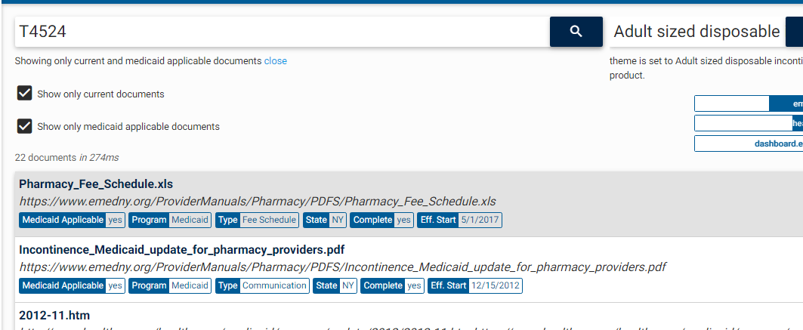

1. Pharmacy_Fee_Schedule.xls

This document mentions other incontinence products along with code T4524. Max unit is given as 250.

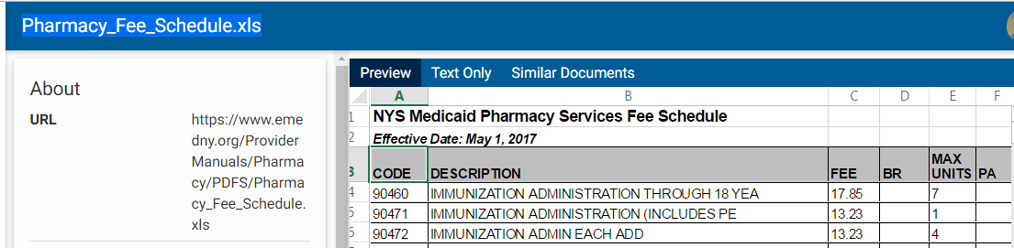

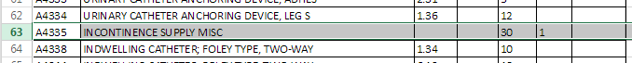



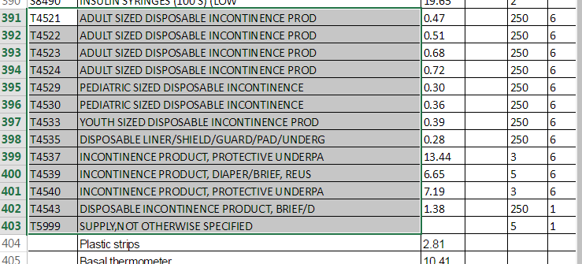

1. DME Fee Schedule 2017

Same information as Pharmacy FS

https://ny-elephant.cotiviti.io/references/87ac9977-3223-3ab9-b2d8-33aa91d7eb6a?q=_medicaidApplicable!%253Dno%2520_current%253Dyes%2520T4524

1. Incontinence_Medicaid_update_for_pharmacy_providers.pdf

This document mentions incontinence products codes - A4335, A4554, T4521, T4522, T4523, T4524, T4529, T4530, T4533, T4535, T4537, T4539, T4540, and T4543.

<https://ny-elephant.cotiviti.io/references/98583c7e-4bb9-3f6a-b882-d5b21d370048?q=_medicaidApplicable!%253Dno%2520_current%253Dyes%2520T4524>

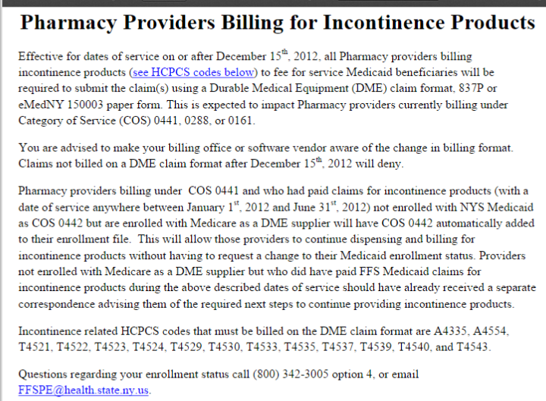

1. continence Supply Management Program Fee Schedule Changes

This Feb 2017 document mentions same codes under incontinence supply except A4335.

<https://ny-elephant.cotiviti.io/references/03af328c-9987-3a50-837d-530516137f0f?q=_medicaidApplicable!%253Dno%2520_current%253Dyes%2520T4524>

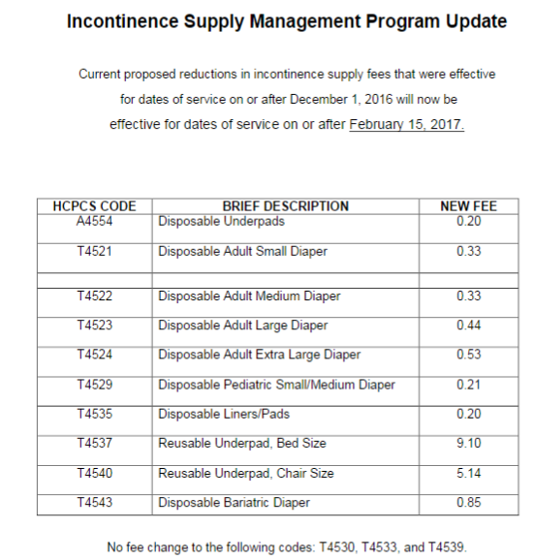

1. Practitioners Ordering Incontinence Products

This document mentions ICD10 codes as indication for incontinence product prescription.

<https://ny-elephant.cotiviti.io/references/c290343e-e73c-3590-b648-f20ef6b4b444?q=_medicaidApplicable!%253Dno%2520_current%253Dyes%2520T4524>

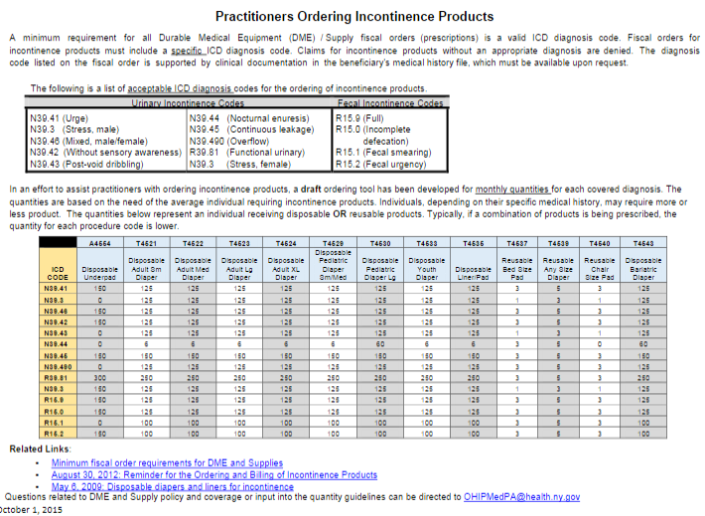

N39.41 (Urge)

N39.3 (Stress, male)

N39.46 (Mixed, male/female)

N39.42 (Without sensory awareness)

N39.43 (Post-void dribbling)

N39.44 (Nocturnal enuresis)

N39.45 (Continuous leakage)

N39.490 (Overflow)

R39.81 (Functional urinary)

N39.3 (Stress, female

R15.9 (Full)

R15.0 (Incomplete defecation)

R15.1 (Fecal smearing)

R15.2 (Fecal urgency)

# Information taken for further review:

1. Pharmacy Fee Schedule 2017

Incontinence product codes with Max units 250: - T4521, T4522, T4523, T4524, T4529, T4530, T4533, T4535, T4543

Incontinence products, underpants - T4537, T4539, T4540

1. Pharmacy Providers Billing for Incontinence Products

In addition to above codes - A4335, A4554

1. Practitioners Ordering Incontinence Products

N39.41 (Urge)

N39.3 (Stress, male)

N39.46 (Mixed, male/female)

N39.42 (Without sensory awareness)

N39.43 (Post-void dribbling)

N39.44 (Nocturnal enuresis)

N39.45 (Continuous leakage)

N39.490 (Overflow)

R39.81 (Functional urinary)

N39.3 (Stress, female

R15.9 (Full)

R15.0 (Incomplete defecation)

R15.1 (Fecal smearing)

R15.2 (Fecal urgency)

# Search terms used for review:

A4335, A4554, T4521, T4522, T4523, T4524, T4529, T4530, T4533, T4535, T4537, T4539, T4540, and T4543

Incontinence AND supply – 52

Incontinence AND product – 46

1750 AND (disposable AND diaper) – 4

# Documents for each search term:

A4335 – 13 current applicable documents.

A4554 – 24

T4521 – 24

T4522 – 22

T4523 – 22

T4524 – 22

T4529 – 22

T4530 – 22

T4533 – 24

T4535 – 24

T4537 – 24

T4539 – 24

T4540 – 24

T4543 – 24

T4533 AND !T4530 – 2 - (<https://ny-elephant.cotiviti.io/references;q=_medicaidApplicable!%253Dno%2520_current%253Dyes%2520T4533%2520AND%2520!T4530>)

Incontinence AND supply – 52

New information - <https://ny-elephant.cotiviti.io/references/a71ee982-6db5-3240-8a93-305f65a8e226?q=_current%253Dyes%2520_medicaidApplicable!%253Dno%2520Incontinence%2520AND%2520supply>

<https://ny-elephant.cotiviti.io/references/469ee6a1-3d02-3f24-8d1d-65ec9e8afa3e?q=_current%253Dyes%2520_medicaidApplicable!%253Dno%2520Incontinence%2520AND%2520supply>

# Supporting information:

1. DME Procedure Codes Manual

<https://ny-elephant.cotiviti.io/references/df6e556d-c40f-3e66-9573-bc387b0e9b13?q=_medicaidApplicable!%253Dno%2520_current%253Dyes%2520T4524>

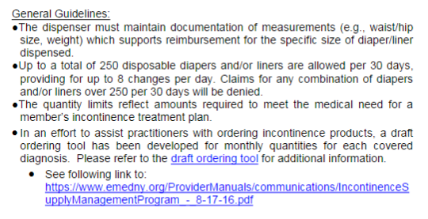

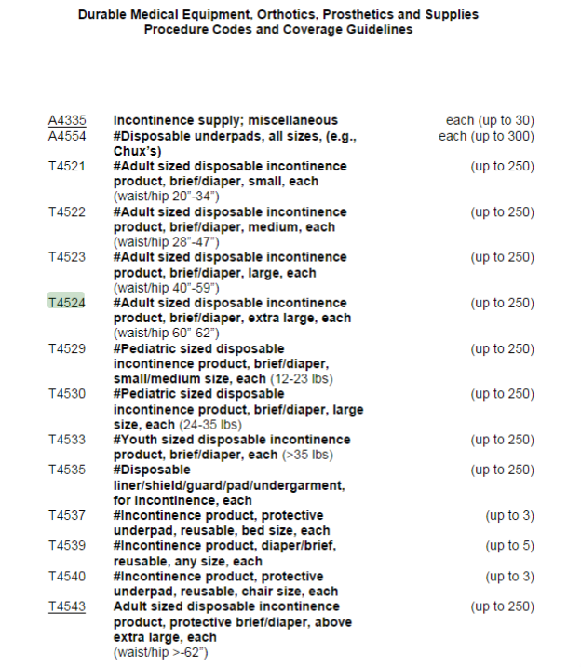

1. Pharmacy Procedure Code Manual

Similar information in- Pharmacy Procedure code

<https://ny-elephant.cotiviti.io/references/aca2fe44-447a-34ef-b1d6-9b8da87f6e9b?q=_medicaidApplicable!%253Dno%2520_current%253Dyes%2520T4524>

1. Pharmacy Providers: Utilization Review Limits for Incontinence Products

<https://ny-elephant.cotiviti.io/references/89ec32c3-09b5-39c6-a65e-300e0615930b?q=_medicaidApplicable!%253Dno%2520_current%253Dyes%2520A4554>

Old Document but Supports combination logic

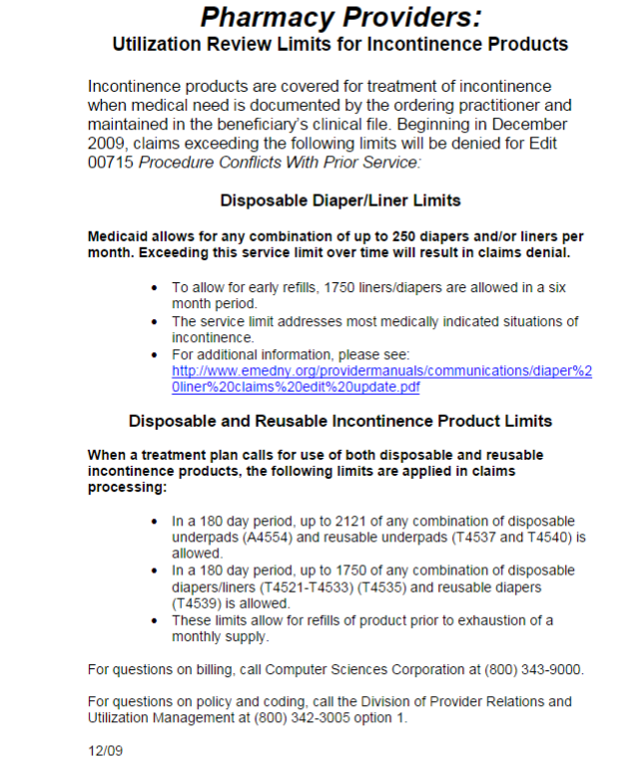

<https://ny-elephant.cotiviti.io/references/058d29a7-9cf6-3466-894d-c8d64a923ba5?q=_medicaidApplicable!%253Dno%2520_current%253Dyes%2520T4533%2520AND%2520!T4530>

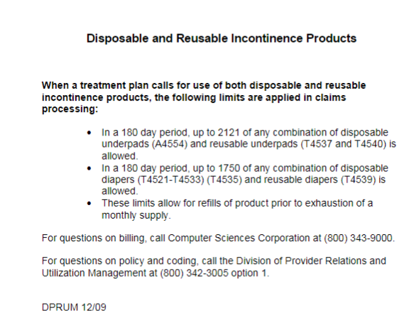

1. New edition of “Incontinence Supply Management Program Revised Fee Schedule Changes”

<https://ny-elephant.cotiviti.io/references/311269a7-be59-3c53-a542-482ab5ca179e?q=_medicaidApplicable!%253Dno%2520_current%253Dyes%2520A4554>

1. diaper%20liner%20claims%20edit%20update.pdf

<https://ny-elephant.cotiviti.io/references/469ee6a1-3d02-3f24-8d1d-65ec9e8afa3e?q=_current%253Dyes%2520_medicaidApplicable!%253Dno%2520Incontinence%2520AND%2520supply>

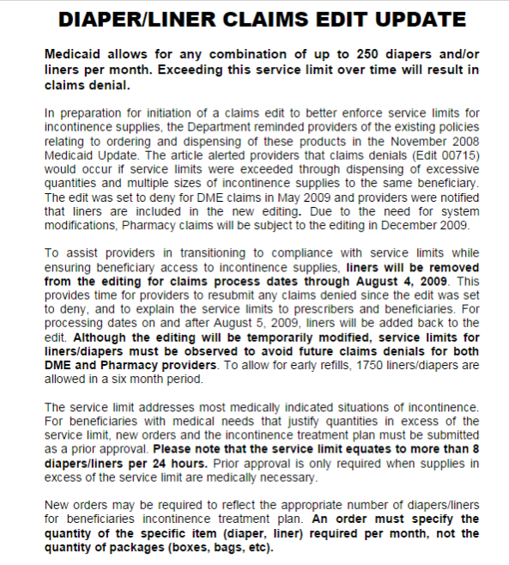

1. Incontinence_Prov_Comm_8-30-12.pdf

<https://ny-elephant.cotiviti.io/references/a71ee982-6db5-3240-8a93-305f65a8e226?q=_current%253Dyes%2520_medicaidApplicable!%253Dno%2520Incontinence%2520AND%2520supply&tab=preview>

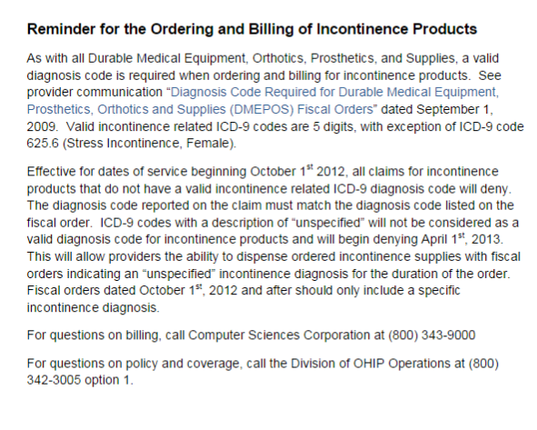

1. Disposable%20Diapers%20and%20Liners%20for%20Incontinence.pdf

<https://ny-elephant.cotiviti.io/references/209b9598-ded5-3ea0-99a0-259c80be3fef?q=_current%253Dyes%2520_medicaidApplicable!%253Dno%2520Incontinence%2520AND%2520product>

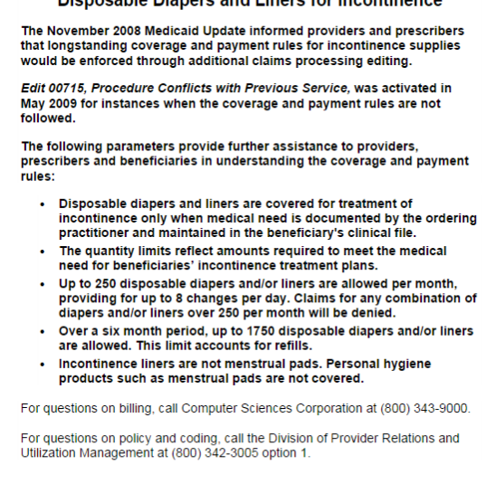

# Opposing information:

1. DME Procedure Codes

<https://ny-elephant.cotiviti.io/references/df6e556d-c40f-3e66-9573-bc387b0e9b13?q=_medicaidApplicable!%253Dno%2520_current%253Dyes%2520T4524>

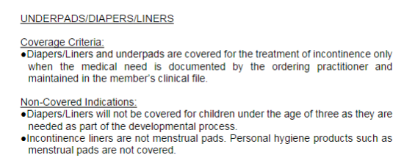

# Final conclusion:

State provides information about incontinence products, max units and diagnosis requirements.

Max Units: Although, state specifies max units of individual CPTs but it also mentioned in 2009 documents that they will allows providers to bill bigger quantities within 180 days for refill. Although these documents are old but they are still referenced in some of the new state documents. We need to be lenient in deciding max units quantities so that claims do not get denied on monthly basis.

Diagnosis Requirement: State specifies diagnosis codes which are required to be included in claim for billing incontinence products. State also specifies the number of products that can be billed for each diagnosis code.

There is scope for creating more than one rule here.

# Logic:

1. If the following incontinence product codes are billed by any provider with greater than 2121 combined units in 180 days, then deny additional units with reason Adjusted Units Because They Exceeded The Amount Allowed. Codes: A4554, T4537, T4540
2. If the following incontinence product codes are billed by any provider with greater than 1750 combined units in 180 days, then deny additional units with reason Adjusted Units Because They Exceeded The Amount Allowed. Codes: T4521-T4533, T4535, T4539
3. If any of the following incontinence product codes is billed and an appropriate diagnosis code is not submitted on the claim header then deny the line with reason The Diagnosis Codes On The Claim Do Not Support The Billed Procedure Code.

HCPCS: A4554, T4521, T4522, T4523, T4524, T4529, T4530, T4533, T4535, T4537, T4539, T4540, and T4543

ICD: N39.41, N39.3, N39.46, N39.42, N39.43, N39.44, N39.45, N39.490, R39.81, N39.3, R15.9, R15.0, R15.1, R15.2

1. If incontinence products are billed by any provider and patients age is less than 3 years then deny the billed code with reason inappropriate billing. HCPCS: A4554, T4521, T4522, T4523, T4524, T4529, T4530, T4533, T4535, T4537, T4539, T4540, and T4543.

Or

1. If disposable incontinence product codes (T4521, T4522, T4523, T4524, T4529, T4530, T4533, T4535, T4543) are billed in any combination by any provider with greater than 250 units in 28 days, then deny additional units with reason Adjusted Units Because They Exceeded The Amount Allowed.
2. If reusable incontinence product codes (T4537, T4539, T4540) are billed in any combination by any provider with greater than 5 units in 28 days, then deny additional units with reason Adjusted Units Because They Exceeded The Amount Allowed.
3. If disposable incontinence product codes (A4554, A4335) is/are billed in any combination by any provider with greater than 300 units in 28 days, then deny additional units with reason Adjusted Units Because They Exceeded The Amount Allowed.

*A4335 has max units 30.